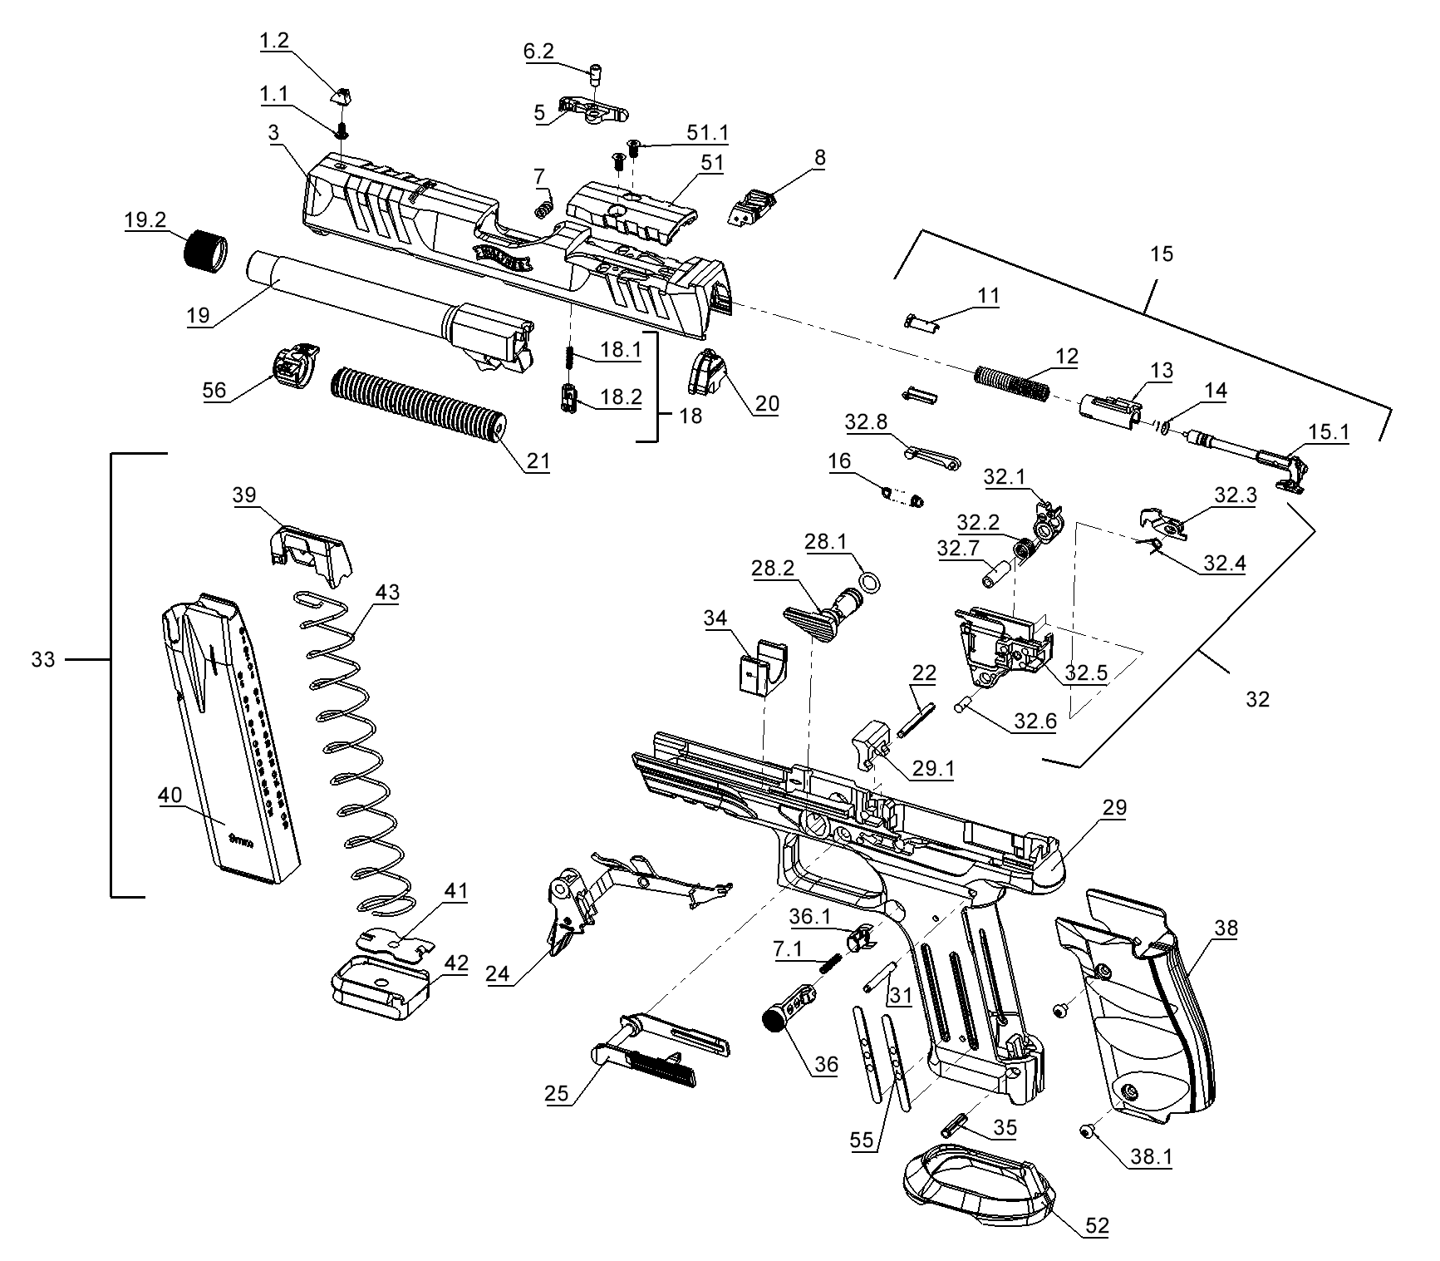

|  |  |  |  |  |
| --- | --- | --- | --- | --- |
| **P. NR.** | **SACHNR.** | **Benennung** | **Designation** | **PG** |
| 1.1 | 284 74 69 | Kornschraube für Kunststoff | Screw, front sight for plastic |  |
| 1.2 | 284 88 30 | Korn 4,9 mm | Front sight 4,9 mm |  |
| 3 | 287 94 09 | Verschluss 9x19 4,5“ (OR) ET1) | Slide 9x19 4,5“ (49mm Cutout) ET1) |  |
| 3 | 287 93 87 | Verschluss 9x19 5.0“ (OR) ET1) | Slide 9x19 5.0“ (49mm Cutout) ET1) |  |
| 5 | 284 84 49 | Auszieher 9mmx19 | Extractor 9mmx19 |  |
| 6.2 | 262 75 66 | Auszieherstift | Extractor plunger |  |
| 7 | 285 20 47 | Druckfeder zum Auszieher | Spring for extractor |  |
| 7 | 287 58 96 | Druckfeder zum Auszieher | Spring for extractor |  |
| 7.1 | 280 56 42 | Magazinhalterfeder | Spring for magazine release |  |
| 8 | 284 74 85 | Visier Kunststoff | Rear sight plastic |  |
| 11 | 280 42 55 | Federstütze | Striker spring keeper |  |
| 12 | 262 73 70 | Schlagfeder | Striker spring |  |
| 13 | 262 73 53 | Stützhülse | Striker guide |  |
| 14 | 262 73 37 | Rückspringfeder | Striker return spring |  |
| 15 | 280 79 98 | Schlagbolzen kpl. | Striker assembly |  |
| 15.1 | 280 79 21 | Schlagbolzen | Striker |  |
| 16 | 283 29 76 | Abzugfeder | Trigger return spring |  |
| 18 | 281 10 31 | Schlagbolzensicherung kpl. | Safety plunger assembly |  |
| 18.1 | 276 27 81 | Feder zur Schlagbolzensicherung | Spring for safety plunger |  |
| 18.2 | 286 44 95 | Schlagbolzensicherung M2 AFC | Safety plunger |  |
| 19 | 289 08 61 | Lauf 9x19 4.5” ET1) | Barrel 9x19 4.5” ET1) |  |
| 19 | 289 04 96 | Lauf 9x19 5.0” ET1) | Barrel 9x19 5.0” ET1) |  |
| 19.2 | 278 35 41 | Kappe SD-Lauf | Cap SD-Barrel |  |
| 20 | 284 72 64 | Verschlusskappe | Slide end cap |  |
| 21 | 283 02 48 | Schließfedereinheit Steelframe mont. | Recoil guide rod Steelframe assembly |  |
| 22 | 262 54 58 | Spannstift 3x28 | Pin 3x28 |  |
| 24 | 284 63 57 | Abzug (DPT) grau | Trigger assembly (DPT) grey |  |
| 24 | 287 59 34 | Abzug kompl. (PDT SF) | Trigger assembly (PDT SF) |  |
| 24 | 284 63 49 | Abzug (DPT) schwarz | Trigger assembly (DPT) black |  |
| 25 | 277 00 24 | Fanghebel kpl. AM | Slide stop lever assembly AM |  |
| 28.1 | 278 38 60 | O-Ring 6,5x1,5 | O-Ring 6,5x1,5 |  |
| 28.2 | 284 66 32 | Laufhalter SF | Barrel lock |  |
| 29 | 287 94 25 | Griffstück FS 4.5“ ET1) | Frame C 4.5“ ET1) |  |
| 29 | 287 93 95 | Griffstück FS 5.0“ ET1) | Frame FS 5.0“ ET1) |  |
| 29.1 | 288 40 62 | Laufauflager SF | Locking block |  |
| 30 | 283 00 51 | Fanghebelfeder SF | Slide stop lever spring |  |
| 31 | 276 28 38 | Spannstift 3x24 | Pin 3x24 |  |
| 32 | 287 16 45 | Abzuggehäuse | Adjustable sear housing assembly |  |
| 32 | 285 11 48 | Abzuggehäuse (PDT) 2) | Adjustable sear housing assembly (PDT) 2) |  |
| 32 | 287 16 45 | Abzugsgehäuse DPT WAI (nur USA) | Sear housing assembly DPT WAI  (only USA) |  |
| 32 | 284 90 62 | Abzugsgehäuse DPT INT (international) | Sear housing assembly DPT INT  (international) |  |
| 32.1 | 284 71 83 | Stütze | Single action lever |  |
| 32.2 | 284 71 91 | Feder zur Stütze | Spring for single action lever |  |
| 32.3 | 269 82 93 | Fangstück für Standardmodelle2) | Single action sear for standard models2) |  |
| 32.3 | 284 07 58 | Fangstück für Pro SD Modelle | Single action sear for Pro SD models |  |
| 32.4 | 262 45 67 | Feder zum Fangstück | Spring for single action sear |  |
| 32.5 | 284 81 71 | Abzuggehäuse | Sear housing |  |
| 32.6 | 262 45 41 | Stift zum Fangstück | Sear pin |  |
| 32.7 | 265 64 77 | Hülse zum Abzuggehäuse | Single action lever pin |  |
| 32.8 | 283 86 30 | Steuerung | trigger bar guide |  |
| 33 | 286 54 41 | Magazin 9mm 10R FS | Magazine 9mm 10R C |  |
| 33 | 286 66 84 | Magazin 9mm 10R 2021 FS | Magazine 9mm 10R 2021 FS |  |
| 33 | 286 36 69 | Magazin 9mm 18R FS Alu schwarz | Magazine 9mm 18R FS Alu black |  |
| 33 | 287 91 82 | Magazin 9mm 20R FS Alu schwarz | Magazine 9mm 20R FS Alu black |  |
| 34 | 283 01 16 | Einlage Verschlussführung | Insert |  |
| 35 | 278 87 72 | Spannstift 4x16 | Pin 4x16 |  |
| 36 | 284 86 35 | Magazinhalter | Magazine release |  |
| 36.1 | 279 09 80 | Magazinhalterfixierung | Magazine release keeper |  |
| 38 | 287 22 77 | Griffrücken Steelframe | Backstrape Steelframe |  |
| 38 | 288 99 19 | Griffschale Alu schwarz | Backstrape Alu black |  |
| 38.1 | 283 04 93 | Schraube Griffschale | Screw grip panel |  |
| 39 | 270 81 59-NA | Zubringer | Follower |  |
| 39 | 285 50 89 | Zubringer 10R schwarz C&FS; C&FS Alu | Follower 10R black C&FS; C&FS Alu |  |
| 40 | 284 98 95 | Magazingehäuse 18R 20R FS | Magazine tube 18R FS |  |
| 40 | 286 57 51 | Magazingehäuse 10R C&FS; C&FS Alu | Magazine tube 10R C&FS; C&FS Alu |  |
| 41 | 267 00 89 | Bodenhalter | Magazine butt plate keeper |  |
| 41 | 286 76 64 | Bodenhalter 10R C&FS; C&FS Alu | Magazine butt plate keeper 10R C&FS; C&FS Alu |  |
| 41 | 287 91 74 | Bodenhalter 20R 9mm | Magazine butt plate keeper 20R 9mm |  |
| 42 | 286 31 89 | Magazinboden FS 18R Alu Pro SD | Magazine butt plate FS 18R Alu Pro SD |  |
| 42 | 286 57 77 | Magazinboden 9mm 10R 2021 | Magazine butt plate 9mm 10R 2021 |  |
| 42 | 286 66 68 | Magazinboden 9mm 10R 2021 Alu | Magazine butt plate 9mm 10R 2021 Alu |  |
| 42 | 287 62 81 | Magazinboden 9mm 20 R Alu schwarz | Magazine butt plate 9mm 20R Alu black |  |
| 43 | 286 57 69 | Magazinfeder 10R C&FS; C&FS Alu | Magazine spring 10R C&FS; C&FS Alu |  |
| 43 | 287 99 64 | Magazinfeder 18R C&FS | Magazine spring 18R C&FS |  |
| 43 | 287 91 66 | Magazinfeder 20R 9mm | Magazine spring 20R 9mm |  |
| 51 | 286 78 34 | Abdeckplatte L≈49mm | Cover Plate L≈49mm |  |
| 51.1 | 285 91 57 | Schraube für Adapterplatte | Screw, Cover Plate |  |
| 52 | 287 58 88 | Magwell Steelframe | Flored Magwell Steelframe |  |
| 55 | 283 02 30 | Magazinführung SF | Magazine guide |  |
| 56 | 287 23 40 | Damper Insert 5.0 Zoll | Damper Insert 5.0“ |  |
| 56 | 287 23 31 | Damper Insert 4.5 Zoll | Damper Insert 4.5“ |  |

